
Traits UI User Guide
Lyn Pierce
Version 2
8-Mar-07

© 2005, 2007 Enthought, Inc.
All Rights Reserved.
Redistribution and use of this document in source and derived forms, with or without modification, are permitted provided that the following conditions are met:
Redistributions of source or derived format (for example, Portable Document Format or Hypertext Markup Language) must retain the above copyright notice, this list of conditions and the following disclaimer.
Neither the name of Enthought, Inc., nor the names of contributors may be used to endorse or promote products derived from this document without specific prior written permission.
THIS DOCUMENT IS PROVIDED BY THE COPYRIGHT HOLDERS AND CONTRIBUTORS "AS IS" AND ANY EXPRESS OR IMPLIED WARRANTIES, INCLUDING, BUT NOT LIMITED TO, THE IMPLIED WARRANTIES OF MERCHANTABILITY AND FITNESS FOR A PARTICULAR PURPOSE ARE DISCLAIMED. IN NO EVENT SHALL THE COPYRIGHT HOLDERS OR CONTRIBUTORS BE LIABLE FOR ANY DIRECT, INDIRECT, INCIDENTAL, SPECIAL, EXEMPLARY, OR CONSEQUENTIAL DAMAGES (INCLUDING, BUT NOT LIMITED TO, PROCUREMENT OF SUBSTITUTE GOODS OR SERVICES; LOSS OF USE, DATA, OR PROFITS; OR BUSINESS INTERRUPTION) HOWEVER CAUSED AND ON ANY THEORY OF LIABILITY, WHETHER IN CONTRACT, STRICT LIABILITY, OR TORT (INCLUDING NEGLIGENCE OR OTHERWISE) ARISING IN ANY WAY OUT OF THE USE OF THIS DOCUMENT, EVEN IF ADVISED OF THE POSSIBILITY OF SUCH DAMAGE.
All trademarks and registered trademarks are the property of their respective owners.
Enthought, Inc.
515 Congress Avenue
Suite 2100
Austin TX 78701
1.512.536.1057 (voice)
1.512.536.1059 (fax)
http://www.enthought.com
info@enthought.com
Table of Contents
1 Introduction 1
1.1 The Model-View-Controller (MVC) Design Pattern 1
1.1.1 The Model: HasTraits Subclasses and Objects 2
1.1.2 The View: View Objects 2
1.1.3 The Controller: Handler Subclasses and Objects 2
1.2 Structure of this Guide 3
2 Introduction to the View Object 4
3 The Building Blocks of a View 7
3.1 The Item Object 7
3.1.1 Content Attributes 7
3.1.2 Display Format Attributes 8
3.1.3 Content Format Attributes 8
3.1.4 Attributes for Overriding the Default Widget 9
3.1.5 Visibility and Status Attributes 9
3.1.6 User Help Attributes 10
3.1.7 Unique Id Attribute 10
3.2 The Group Object 10
3.2.1 Content Attributes 11
3.2.2 Group Display Format Attributes 12
3.2.3 Visibility and Status Attributes 12
3.2.4 Group-Level User Help Attributes 13
3.2.5 Unique Id Attribute 13
4 Customizing a View 14
4.1 Specifying Window Type: the ‘kind’ Attribute 14
4.1.1 Dialog boxes: ‘modal’, ‘live’, ‘livemodal’ and ‘nonmodal’ 15
4.1.2 Wizards 15
4.1.3 Panels and Subpanels 16
4.2 Command Buttons: the buttons Attribute 16
4.3 Window Display Details 18
4.4 Window Command Attributes 19
4.5 User Help Attributes 19
4.6 Unique Id Attribute 20
5 Advanced View Concepts 21
5.1 Internal Views 21
5.1.1 Defining a Default View 21
5.1.2 Defining Multiple Views Within the Model 22
5.2 Separating Model and View: External Views 24
5.3 Displaying a View 25
5.3.1 configure_traits() 25
5.3.2 edit_traits() 26
5.3.3 ui() 26
5.4 The View Context 27
5.4.1 Multi-Object Views 28
5.5 Include Objects 30
6 Controlling the Interface: the Handler 32
6.1 Backstage: Introducing the UIInfo Object 33
6.2 Writing Handler Methods 33
6.2.1 Overriding Standard Methods 33
6.2.2 Reacting to Trait Changes 34
6.2.3 Implementing Custom Window Commands 36
6.3 Assigning Handlers to Views 38
6.3.1 Binding a singleton Handler to a View 38
6.3.2 Linking Handler and View at edit time 39
6.3.3 Creating a default View within a Handler 39
7 Introduction to Trait Editors 41
7.1 Specifying an Alternate Trait Editor 42
7.1.1 Initializing Editors 45
7.2 Specifying an Editor Style 45
7.2.1 The “simple” style 45
7.2.2 The “custom” style 46
7.2.3 The “text” style 47
7.2.4 The “readonly” style 48
7.2.5 Using Editor Styles 48
8 The Standard Trait Editors 50
8.1 Basic Trait Editors 50
8.1.1 BooleanEditor 50
8.1.2 ButtonEditor 51
8.1.3 CheckListEditor 52
8.1.4 CodeEditor 53
8.1.5 ColorEditor 55
8.1.6 CompoundEditor 57
8.1.7 DirectoryEditor 57
8.1.8 EnableRGBAColorEditor 59
8.1.9 EnumEditor 60
8.1.10 FileEditor 61
8.1.11 FontEditor 62
8.1.12 KivaFontEditor 64
8.1.13 ListEditor 65
8.1.14 RangeEditor 66
8.1.15 RGBColorEditor 68
8.1.16 RGBAColorEditor 68
8.1.17 SetEditor 70
8.1.18 TextEditor 72
8.1.19 TupleEditor 73
8.2 Advanced Trait Editors 74
8.2.1 CustomEditor 74
8.2.2 DropEditor 74
8.2.3 ImageEnumEditor 74
8.2.4 InstanceEditor 75
8.2.5 PlotEditor 75
8.2.6 TableEditor 75
8.2.7 TreeEditor 75
9 Advanced Editor Concepts 76
9.1 Interacting with an Editor Through the UI Object 76
9.1.1 Accessing Trait Editors Using Item ‘id’s 76
9.1.2 Controlling Editor Status Using ‘enabled/disabled’ 76
9.2 Introduction to Editor Factories 76
9.3 Defining a Custom Editor 76
9.3.1 Defining the Editor Factory 76
9.3.2 Defining the Editor 77
10 Miscellaneous Advanced Topics 78
10.1 The UI Object 78
10.2 The UIInfo Object Revisited 78
10.3 Defining a Custom Help Handler 78
10.4 Saving and Restoring User Preferences 78
10.4.1 Enabling User Preferences for a View 78
11 Tips, Tricks and Gotchas 80
11.1 Getting/Setting Model View Elements 80
11.1.1 trait_views() 80
11.1.2 trait_view() 81
Appendix I: Glossary of Terms 82
Appendix II: Default Editors for Standard Traits 86

Introduction
This guide is designed to act as both tutorial and reference for Traits UI, an open-source package built and maintained by Enthought, Inc. The Traits UI package is a set of GUI (Graphical User Interface) tools designed to complement Traits, another Enthought open-source package that provides manifest typing, validation, and change notification for Python. This guide is intended for readers who are already moderately familiar with Traits; those who are not may wish to refer to the Traits User Manual for an introduction.

The Model-View-Controller (MVC) Design Pattern
A common and well-tested approach to building end-user applications is the MVC (“Model-View-Controller”) design pattern. In essence, the MVC pattern the idea that an application should consist of three separate entities: a model, which manages the data, state, and internal (“business”) logic of the application; one or more views, which format the model data into a graphical display with which the end user can interact; and a controller, which manages the transfer of information between model and view so that neither needs to be directly linked to the other. In practice, particularly in simple applications, the view and controller are often so closely linked as to be almost indistinguishable, but it remains useful to think of them as distinct entities.
The three parts of the MVC pattern correspond roughly to three classes in the Traits and Traits UI packages.
- Model: HasTraits class (Traits package)
- View: View class (Traits UI package)
- Controller: Handler class (Traits UI package)
The remainder of this section gives an overview of these relationships.

The Model: HasTraits Subclasses and Objects
In the context of Traits, a model consists primarily of one or more subclasses or instances of the HasTraits class, whose trait attributes (typed attributes as defined in Traits) represent the model data. The specifics of building such a model are outside the scope of this manual; please see the Traits User Manual for further information.

The View: View Objects
A view for a Traits-based application is an instance of a class called, conveniently enough, View. A View object is essentially a display specification for a GUI window or panel. Its contents are defined in terms of instances of two other classes: Item and Group. These three classes are described in detail in Chapters 3 through 5 of this manual; for the moment, it is important to note that they are all defined independently of the model they are used to display.
Note that the terms “view” and “View” are distinct for the purposes of this document. The former refers to the component of the MVC design pattern; the latter is a Traits UI construct.

The Controller: Handler Subclasses and Objects
The controller for a Traits-based application is defined in terms of the Handler class. Specifically, the relationship between any given View instance and the underlying model is managed by an instance of the Handler class. For simple interfaces, the Handler can be implicit. For example, none of the examples in Chapters 2 through 5 includes or requires any specific Handler code; they are managed by a default Handler that performs the basic operations of window initialization, transfer of data between GUI and model, and window closing. Thus, a programmer new to Traits UI need not be concerned with Handlers at all. Nonetheless, custom handlers can be a powerful tool for building sophisticated application interfaces, as discussed in Chapter 6.

Structure of this Guide
The intent of this guide is to present the capabilities of the Traits UI package in usable increments, so that you can create and display gradually more sophisticated interfaces from one chapter to the next. Thus, Chapters 2 through 5 show how to construct and display views from the simple to the elaborate, while leaving such details as GUI logic and widget selection to system defaults. Chapter 6 explains how to use the Handler class to implement custom GUI behaviors, as well as menus and toolbars. Chapters 7 through 9 show how to control GUI widget selection by means of trait editors. Chapters 10 and 11 cover miscellaneous additional topics. Further reference materials, including a glossary of terms and an API summary for the Traits UI classes covered in this Guide, are located in the Appendices.

Introduction to the View Object
A simple way to edit (or simply observe) the attribute values of a HasTraits object in a GUI window is to call the object’s configure_traits() method. This method constructs and displays a dialog box containing editable fields for each of the object’s trait attributes. For example, the following sample code defines the SimpleEmployee class, creates an object of that class, and constructs and displays a GUI for the object:
Example 1
# Sample code to demonstrate configure_traits()
from enthought.traits.api import HasTraits, Str, Int
import enthought.traits.ui

class SimpleEmployee(HasTraits):
first_name = Str
last_name = Str
department = Str

employee_number = Str
salary = Int

sam = SimpleEmployee()
sam.configure_traits()
Unfortunately, the resulting form simply displays the attributes of the object sam in alphabetical order with little formatting, which is seldom what is wanted:
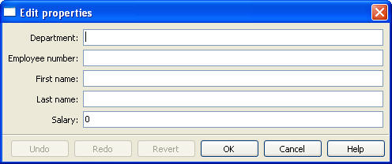
Figure 1
In order to control the layout of the interface, it is necessary to define a View object. A View object is a template for a GUI window or panel. In other words, a View specifies the content and appearance of a TraitsUI window or panel display.
For example, suppose we want to construct a GUI window that shows only the first three attributes of a SimpleEmployee (e.g., because salary is confidential and the employee number should not be edited). Furthermore, we would like to specify the order in which those fields appear. We can do this by defining a View object and passing it to the configure_traits() method:
Example 2
# Sample code to demonstrate configure_traits()
from enthought.traits.api import HasTraits, Str, Int
from enthought.traits.ui.api import View, Item
import enthought.traits.ui

class SimpleEmployee(HasTraits):
first_name = Str
last_name = Str
department = Str

employee_number = Str
salary = Int

view1 = View(Item(name = 'first_name'),
Item(name = 'last_name'),
Item(name = 'department'))

sam = SimpleEmployee()
sam.configure_traits(view=view1)
The resulting window has the desired appearance:
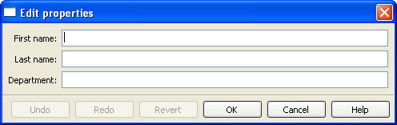
Figure 2
Chapters 3 through 5 explore the contents and capabilities of Views. Refer to the Traits API Reference for details of the View class.
For the time being, all example code will continue to use the configure_traits() method; a detailed description of this and other techniques for creating GUI displays from Views can be found in Section 5.3.

The Building Blocks of a View
The contents of a View are specified primarily in terms of two basic building blocks: Item objects (which, as suggested by Example 2, correspond roughly to individual trait attributes), and Group objects. A given View can contain one or more objects of either of these types, which are specified as arguments to the View constructor as in the case of the three Items in Example 2.
The remainder of this chapter describes the Item and Group classes.

The Item Object
The simplest building block of a View is the Item object. An Item specifies a single interface widget, usually the display for a single trait attribute of a HasTraits object. The content, appearance, and behavior of the widget are controlled by means of the Item object’s attributes, which are usually specified as keyword arguments to the Item constructor, as in the case of name in Example 2.
The remainder of this section describes the attributes of the Item object, grouped by categories of functionality. It is not necessary to understand all of these attributes in order to create useful Items; many of them can usually be left unspecified, as their default values are adequate for most purposes. Indeed, as we have already seen, simply specifying the name of the trait attribute to be displayed is often enough to produce a usable result.
Table 1 lists the attributes of the Item class, organized by functional categories. Refer to the Traits API Reference for details on the Item class.
Table 1
Category | Attributes | Description
Content | - name  - object | These attributes specify the actual data to be displayed by an item. Because an Item is essentially a template for displaying a single trait, its name attribute is nearly always specified.  By contrast, it is often not necessary to assign the object attribute: its default value is the literal string ‘object’, which is assumed to represent the object whose configure_traits() method is using the View. In Example 2, the object attribute of all three items is assumed to be ‘object’, which represents the object sam. Scenarios where an Item’s object attribute must be explicitly assigned are described in Chapter 5.
Display format | - label  - resizable  - emphasized  - padding  - height  - width | In addition to specifying which trait attributes are to be displayed, you might need to adjust the format of one or more of the resulting widgets.  If an Item’s label attribute is specified but not its name, the value of label is displayed as a simple, non-editable string. (This feature can be useful for displaying, comments or instructions in a Traits UI window.)  Under some circumstances, the width and height attributes are ignored. See Section Error: Reference source not found for details
Content format | - format_str  - format_func | In some cases it can be desirable to apply special formatting to a widget’s contents rather than to the widget itself. Examples of such formatting might include rounding a floating-point value to two decimal places, or capitalizing all letter characters in a license plate number.
Widget override | - editor  - style | These attributes override the widget that is automatically selected by Traits UI. These relatively advanced options are mentioned discussed in Chapters 7-9.
Visibility and status | - enabled_when  - visible_when  - defined_when | Use these attributes to create a simple form of a dynamic GUI, which alters the display in response to changes in the data it contains. More sophisticated dynamic behavior can be implemented using a custom Handler (see Chapter 6).
User help | - tooltip  - help  - help_id | These attributes provide guidance to the user in using the user interface. The help_id attribute is ignored by the default help handler, but can be used by a custom help handler.
Unique identifier | - id | This option is needed only for advanced Traits UI applications; see Section 9.1 for an example of its use.  An id value can be used for persisting user preferences about the widget.
format_str:.
format_func:.
enabled_when:.
visible_when:.
help: If the help attribute is not defined for an Item, a system-generated message is used instead.

The Group Object
So far, we have seen how to construct GUI windows that display a simple vertical sequence of widgets using instances of the View and Item classes. For more sophisticated interfaces, though, it is often desirable to treat a group of data elements as a unit for reasons that might be visual (e.g., placing the widgets within a labeled border) or logical (activating or deactivating the widgets in response to a single condition, defining group-level help text). In Traits UI, such grouping is accomplished by means of the Group object.
Consider the following enhancement to Example 2:
Example 3
# Sample code to demonstrate configure_traits()
from enthought.traits.api import HasTraits, Str, Int
from enthought.traits.ui.api import View, Item, Group
import enthought.traits.ui

class SimpleEmployee(HasTraits):
first_name = Str
last_name = Str
department = Str

employee_number = Str
salary = Int

view1 = View(Group(Item(name = 'first_name'),
Item(name = 'last_name'),
Item(name = 'department'),
label = 'Personnel profile',
show_border = True))

sam = SimpleEmployee()
sam.configure_traits(view=view1)
The resulting GUI window shows the same widgets as before, but they are now enclosed in a visible border with a text label:
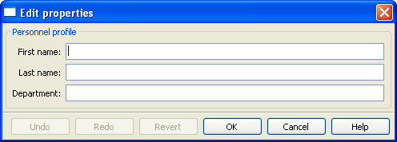
Figure 3

Content of a Group
The content of a Group object is specified exactly like that of a View object. In other words, one or more Item or Group objects are given as arguments to the Group constructor, e.g., the three Items in Example 3. The objects contained in a Group are called the elements of that Group.

Group Attributes
Table 2 lists the attributes of the Group class, organized by functional categories. As with Item attributes, many of these attributes can be left unspecified for any given Group, as the default values usually lead to acceptable displays and behavior.
See the Traits API Reference for details of the Group class.
Table 2
Category | Attributes | Description
Display format | - label  - show_border  - show_labels  - show_left  - padding  - layout  - selected.  - orientation  - style | These attributes define display options for the group as a whole.
Visibility and status | - enabled_when  - visible_when  - defined_when | These attributes work similarly to the attributes of the same names on the Item class.
User help | - help  - help_id | The help text is used by the default help handler only if the group is the only top-level group for the current View. For example, suppose we have defined help text for a Group called group1. The following View will show this text in its help window:  View(group1)  The following two will not:  View(group1, group2)  View(Group(group1))  The help_id is ignored by the default help handler, but can be used by a custom help handler.
Unique identifier | - id | This option is needed only for advanced Traits UI applications; see Section 9.1 for an example of its use.

Customizing a View
As we have seen in the previous two chapters, it is possible to specify a GUI window in Traits UI simply by creating a View object with the appropriate contents. In designing real-life applications, however, you usually need to be able to control the appearance and behavior of the GUI windows themselves, not merely their content. This chapter covers a variety of options for tailoring the appearance of a window that is created using a View, including the type of window that a View appears in, the command buttons that appear in the window, and the physical properties of the window.

Specifying Window Type: the kind Attribute
Many different types of GUI windows can be used to display the same data content. A form can appear in a dialog box, a wizard, or an embedded panel; dialog boxes can be modal (i.e., stop all other program processing until the box is dismissed) or not, and can interact with live data or with a buffered copy. In Traits UI, a single View can be used to implement any of these options simply by modifying its kind attribute. There are seven possible values of kind:
- ‘modal’
- ‘live’
- ‘livemodal’
- ‘nonmodal’
- ‘wizard’
- ‘panel’
- ‘subpanel’
These alternatives are described below. If the kind attribute of a View object is not specified, the default value is ‘modal’.

Dialog boxes: ‘modal’, ‘live’, ‘livemodal’, and ‘nonmodal’
As mentioned above, the behavior of a Traits UI dialog box can vary over two significant degrees of freedom. First, it can be modal, meaning that when the dialog appears, all other GUI interaction is suspended until the dialog window is closed; if it is not modal, then both the window and the rest of the GUI remain active and responsive. Second, it can be live, meaning that any changes that the user makes to data in the window is applied directly and immediately to the underlying model object or objects; otherwise the changes are made to a copy of the model data, and are only copied to the model when the user commits them (usually by clicking an OK or Apply button; see Section 4.2). The four possible combinations of these behaviors correspond to four of the possible values of the ‘kind’ attribute of the View object, as shown Table 3.
Table 3
 | not modal | modal
not live | nonmodal | modal
live | live | livemodal
All four of these dialog types are identical in appearance. Also, all four support the buttons attribute, which is described in Section 4.2.

Wizards
Unlike a dialog box, whose contents generally appear as a single page or a tabbed display , a wizard is presented as a series of pages that a user must navigate sequentially.
Traits UI Wizards are always modal and live. They always display a standard wizard button set; i.e., they ignore the buttons View attribute. In short, wizards are considerably less flexible than dialog windows, and are primarily suitable for highly controlled user interactions such as software installation.

Panels and Subpanels
Both dialogs and wizards are individual GUI windows that appear separately from the main program display, if any. Often, however, you might need to create a window element that is embedded in a larger display. For such cases, the kind of the corresponding View object should be ‘panel’ or ‘subpanel’.
A panel is very similar to a dialog, except that it is embedded in a larger window, which need not be a Traits UI window. Like dialogs, panels support the buttons View attribute, as well as any menus and toolbars that are specified for the View (see Section 6.2.3). Panels are always live and nonmodal.
A subpanel is almost identical to a panel. The only difference is that subpanels do not display command buttons even if the View specifies them.

Command Buttons: the buttons Attribute
A common feature of many GUI windows is a row of command buttons along the bottom of the frame. These buttons have a fixed position outside any scrolled panels in the window, and are thus always visible while the window is displayed. They are usually used for window-level commands such as committing or cancelling the changes made to the form data, or displaying a help window.
In Traits UI, these command buttons are specified by means of the View object’s buttons attribute, whose value is a list of buttons to display. Consider the following variation on Example 3:
Example 4
# Sample code to demonstrate configure_traits()
from enthought.traits.api import HasTraits, Str, Int
from enthought.traits.ui.api import View, Item
from enthought.traits.ui.menu import OKbutton, CancelButton

class SimpleEmployee(HasTraits):
first_name = Str
last_name = Str
department = Str

employee_number = Str
salary = Int

view1 = View(Item(name = 'first_name'),
Item(name = 'last_name'),
Item(name = 'department'),
buttons = [OKButton, CancelButton])

sam = SimpleEmployee()
sam.configure_traits(view=view1)
The resulting window has the same content as before, but only two buttons are displayed at the bottom: OK and Cancel:
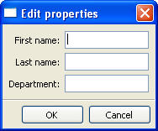
Figure 4
Notice that the automatically sized window is significantly smaller than the one in the original example. See Section 4.3 for details on how to override automatic sizing.
There are six standard buttons defined by Traits UI:
- UndoButton
- ApplyButton
- RevertButton
- OKButton.
- CancelButton –
- HelpButton.
Alternatively, there are several pre-defined button lists that can be imported from enthought.traits.ui.menu and assigned to the buttons attribute:
- OKCancelButtons = [OKButton, CancelButton ]
- ModalButtons = [ ApplyButton, RevertButton, OKButton, CancelButton, HelpButton ]
- LiveButtons = [ UndoButton, RevertButton, OKButton, CancelButton, HelpButton ]
Thus, we could rewrite the highlighted lines in Example 4 as follows, and the effect would be exactly the same:
from enthought.traits.ui.menu import OKCancelButtons
.
.
.
buttons = OKCancelButtons
Finally, the special constant NoButtons can be used to create a dialog without command buttons. Note that buttons = NoButtons is not equivalent to buttons = []. Setting the buttons attribute to an empty list has the same effect as not defining it at all: the default buttons (Figures 1-3) are used.
It is also possible to define custom buttons and add them to this list; see Section 6.2.3.2 for details.

Other View Attributes
Table 4
Category | Attributes | Description
Window display | - x  - y  - width  - height  - title  - resizable  - scrollable  - style  - dock | These attributes control the visual properties of the GUI window itself, regardless of its content.
Command | - handler  - menubar  - toolbar | Traits UI menus and toolbars are generally implemented in conjunction with custom Handlers; see Section 6.2.3.2 for details.
User help | - help  - help_id
Unique identifier | - id

Advanced View Concepts
The first four chapters of this Guide have given an overview of how to use the View class to quickly construct a simple GUI window for a single HasTraits object. This chapter explores a number of more complex techniques that significantly increase the power and versatility of the View object .

Internal Views
In the examples thus far, the View objects have been external. That is to say, they have been defined outside the model (HasTraits object or objects) that they are used to display. This approach is in keeping with the separation of the two concepts prescribed by the MVC design pattern.
There are cases in which it is useful to define a View within a HasTraits class. In particular, it can be useful to associate one or more Views with a particular type of object so that they can be incorporated into other parts of the application with little or no additional programming. Further, a View that is defined within a model class is inherited by any subclasses of that class, a phenomenon called visual inheritance.

Defining a Default View
It is easy to define a default view for a HasTraits class: simply create a View attribute called traits_view for that class. Consider the following variation on Example 3:
Example 5
# Sample code to demonstrate the use of 'traits_view'
from enthought.traits.api import HasTraits, Str, Int
from enthought.traits.ui.api import View, Item, Group
import enthought.traits.ui

class SimpleEmployee2(HasTraits):
first_name = Str
last_name = Str
department = Str

employee_number = Str
salary = Int

traits_view = View(Group(Item(name = 'first_name'),
Item(name = 'last_name'),
Item(name = 'department'),
label = 'Personnel profile',
show_border = True))

sam = SimpleEmployee2()
sam.configure_traits()
In this example, configure_traits() no longer requires a view keyword argument; the traits_view attribute is used by default, resulting in the same display we saw in Figure 3:
Figure 5
It is not strictly necessary to call this View attribute traits_view. If exactly one View attribute is defined for a HasTraits class, that View will always be treated as the default display template for the class. However, if there are multiple View attributes for the class (as discussed in the next section), if one is named “traits_view”, it is always used as the default.

Defining Multiple Views Within the Model
Sometimes it is useful to have more than one pre-defined view for a model class. In the case of our SimpleEmployee, we might want to have both a “public information” view like the one above and an “all information” view. We can do this by simply adding a second View attribute:
Example 6
# Sample code to demonstrate the use of multiple views
from enthought.traits.api import HasTraits, Str, Int
from enthought.traits.ui.api import View, Item, Group
import enthought.traits.ui

class SimpleEmployee3(HasTraits):
first_name = Str
last_name = Str
department = Str

employee_number = Str
salary = Int

traits_view = View(Group(Item(name = 'first_name'),
Item(name = 'last_name'),
Item(name = 'department'),
label = 'Personnel profile',
show_border = True))

all_view = View(Group(Item(name = 'first_name'),
Item(name = 'last_name'),
Item(name = 'department'),
Item(name = 'employee_number'),
Item(name = 'salary'),
label = 'Personnel Database' +
'Entry',
show_border = True))
As before, a simple call to configure_traits() for an object of this class will produce a window based on the default View (traits_view). In order to use the alternate View, we use the same syntax as for an external view, except that the View name is specified in single quotes to indicate that it is associated with the object rather than being a module-level variable:
configure_traits(view='all_view').
Note that if more than one View is defined for a model class, we must indicate which one is to be used as the default by naming it traits_view. Otherwise, Traits UI will give preference to none of them, and will instead try to construct a default View, resulting in a simple alphabetized display as described in Chapter 2. For this reason, it is usually preferable to name a model's default View “traits_view” even if there are no other Views; otherwise, simply defining additional Views—even if they are never used—can unexpectedly change the behavior of the GUI.

Separating Model and View: External Views
In all the examples we have seen so far, the concepts of model and view have remained closely coupled. In some cases the view has been defined in the model class as in Section 5.1; in other cases the configure_traits() method that produces a GUI window from a View has been called from a HasTraits object. However, these strategies are simply conveniences; they are not an intrinsic part of the relationship between model and view in Traits UI. This section begins to explore how the Traits UI package truly supports the separation of model and view prescribed by the MVC design pattern.
An external view is one that is defined outside the model classes. In Traits UI, you can define a named View wherever you can define a variable or class attribute. A View can even be defined in-line as a function or method argument, for example:
object.configure_traits(view=View(Group(Item(name='a'),
Item(name='b'),
Item(name='c')))
However, this approach is apt to obfuscate the code unless the View is very simple.
We have already seen simple examples of external Views defined as variables in Examples 2-4. One advantage of this convention is that the variable name provides an easily accessible “handle” for re-using the View. This technique does not, however, support visual inheritance.
A powerful alternative is to define a View within the controller (Handler) class that controls the GUI window for that View. This technique is described in Chapter 6.

Displaying a View
Traits UI provides three methods for creating a window or panel from a View object. The first two, configure_traits() and edit_traits(), are defined on the HasTraits class, which is a superclass of all Traits-based model classes, as well as of Handler and its subclasses. The third method, ui(), is defined on the View class itself.

configure_traits()
The configure_traits() method creates a standalone window for a given View object, i.e., it does not require an existing GUI to run in. It is therefore suitable for building command-line functions, as well as providing an accessible tool for the beginning Traits UI programmer.
The configure_traits() method also provides options for saving trait attribute values to and restoring them from a file. Refer to the Traits API Reference for details.

edit_traits()
The edit_traits() method is very similar to configure_traits(), with two major exceptions. First, it is designed to run from within a larger application whose GUI is already defined. Second, it does not provide options for saving data to and restoring data from a file, as it is assumed that these operations will be handled elsewhere in the application.

ui()
The View object includes a method called ui(), which performs the actual generation of the GUI window or panel from the View for both edit_traits() and configure_traits(). The ui() method is also available directly through the Traits UI API, though it is usually preferable to use one of the other two methods.
The ui() method has five keyword parameters:
- kind
- context
- handler
- parent
- view_elements
The first four are identical in form and function to the corresponding arguments of edit_traits(), except that context is not optional; we will see why in the next section.
The fifth argument, view_elements, is used only in the context of a call to ui() from a model object method, i.e., from configure_traits() or edit_traits(), Therefore it is irrelevant in the rare cases when ui() is used directly by client code. It contains a dictionary of the named ViewElement objects defined for the object whose configure_traits() (or edit_traits()) method was called..

The View Context
All three of the methods described in Section 5.3 have a context parameter. This parameter can be a single object or a dictionary of string/object pairs; the object or objects are the model objects whose traits attributes are to be edited. In general a “context” is a Python dictionary whose keys are strings; the key strings are used to look up the values. In the case of the context parameter to the ui() method, the dictionary values are objects. In the special case where only one object is relevant, it can be passed directly instead of wrapping it in a dictionary.
When the ui() method is called from configure_traits() or edit_traits() on a HasTraits object, the relevant object is the HasTraits object whose method was called. For this reason, you do not need to specify the context argument in most calls to configure_traits() or edit_traits(). However, when you call the ui() method on a View object, you must specify the context parameter, so that the ui() method will have references to the objects whose trait attributes you want to modify.
So, if configure_traits() figures out the relevant context for you, why would you call ui() at all? One answer lies in multi-object views.

Multi-Object Views
A multi-object view is any view whose contents depend on multiple “independent” model objects, i.e., objects that are not attributes of one another. For example, suppose we are building a real estate listing application, and want to display a window that shows two properties side by side for a comparison of price and features. This is straightforward in Traits UI, as the following example shows:
Example 7
#Sample code to show multi-object view with context

from enthought.traits.api import HasTraits, Str, Int, Bool
from enthought.traits.ui.api import View, Group, Item

# Sample class
class House(HasTraits):
address = Str
bedrooms = Int
pool = Bool
price = Int

# View object designed to display two objects of class 'House'
comp_view = View(Group(Group(Item(name = 'address',
object='h1',
resizable=True),
Item(name = 'bedrooms',
object='h1'),
Item(name = 'pool',
object='h1'),
Item(name = 'price',
object='h1'),
show_border = True),
Group(Item(name = 'address',
object='h2',
resizable=True),
Item(name = 'bedrooms',
object='h2'),
Item(name = 'pool',
object='h2'),
Item(name = 'price',
object='h2'),
show_border = True),
orientation = 'horizontal'),
title = 'House comparison')

# A pair of houses to demonstrate the View
house1 = House(address='4743 Dudley Lane',
bedrooms=3,
pool=False,
price=150000)
house2 = House(address='11604 Autumn Ridge',
bedrooms=3,
pool=True,
price=200000)

# ...And the actual display command
house1.configure_traits(view=comp_view, context={'h1':house1,
'h2':house2})
The resulting GUI window has the desired appearance:
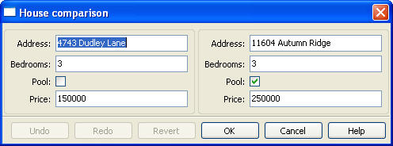
Figure 6
For the purposes of this particular example, it makes sense to create a separate Group for each model object, and to use two model objects of the same class. Note, however, that neither is a requirement. It is only necessary for the object attribute of each Item to be represented in the context, and for the name of each Item to be an existing attribute of the corresponding object.
Another use for multi-object views is shown in Section 8.1.9.

Include Objects
In addition to the Item and Group class, a third building block class for Views exists in Traits UI: the Include class. For the sake of completeness, this section gives a brief description of Include objects and their purpose and usage. However, they are not commonly used as of this writing, and should be considered unsupported pending redesign.
In essence, an Include object is a placeholder for a named Group or Item object that is specified outside the Group or View in which it appears. For example, the following two definitions, taken together, are equivalent to the third:
Example 8
# This fragment...
my_view = View(Group(Item(name='a'),
Item(name='b')),
Include('my_group'))

# ...plus this fragment...
my_group = Group(Item(name='c'),
Item(name='d'),
Item(name='e'))

#...are equivalent to this:
my_view = View(Group(Item(name='a'),
Item(name='b')),
Group(Item(name='c'),
Item(name='d'),
Item(name='e'))
This opens an interesting possibility when a View is part of a model class: any Include objects belonging to that View can be defined differently for different instances or subclasses of that class. This technique is called view parameterization.
Although the Include class in its present form is unsupported, its use cases are compelling enough that it will almost certainly be re-implemented as a supported feature in the future.

Controlling the Interface: the Handler
Most of the material in the first five chapters is concerned with the relationship between the model and view aspects of the MVC design pattern as supported by Traits UI. It is now time to look at the third aspect: the controller, implemented in Traits UI as an instance of the Handler class.
A controller for an MVC-based application is essentially an event handler for GUI events, i.e., for events that are generated through or by the program interface. Such events can require changes to one or more model objects (e.g., because a data value has been updated) or manipulation of the interface itself (e.g., window closure, dynamic interface behavior). In Traits UI, such actions are performed by a Handler object.
In the examples we have seen so far, the Handler object has been implicit: Traits UI provides a default Handler that takes care of a common set of GUI events including window initialization and closure, data value updates, and button press events for the standard Traits UI window buttons (see Section 4.2).
This chapter explains the features of the Traits UI Handler, and shows how to implement custom GUI behaviors by building and instantiating custom subclasses of the Handler class. The final section of the chapter describes several techniques for linking a custom Handler to the window or windows it is designed to control.

Backstage: Introducing the UIInfo Object
Traits UI supports the MVC design pattern by maintaining the model, view and controller as separate entities. A single View object can be used to construct UI windows for multiple model objects; likewise a single Handler can handle GUI events for windows created using different Views. Thus there is no static link between a Handler and any particular window or model object—yet, in order to be useful, it must be able to observe and manipulate both. In Traits UI, this is accomplished by means of the UIInfo object.
Whenever Traits UI creates a window or panel from a View, a UIInfo object is created to act as the Handler’s reference to that window and to the object displayed in it. Each entry in the View’s context (see Section 5.4) becomes an attribute of the UIInfo object. For example, the UIInfo object created in Example 7 has attributes h1 and h2 whose values are the objects house1 and house2 respectively. In Example 1 through Example 6, the created UIInfo object has an attribute object whose value is the object sam.
Whenever a window event causes a Handler method to be called, Traits UI passes the corresponding UIInfo object as one of the method arguments. This gives the Handler the information necessary to perform its tasks, as described in the next two sections.

Writing Handler Methods

Overriding Standard Methods
The Handler class provides methods that are automatically executed at certain points in the lifespan of the UI window controlled by a given Handler. By overriding these methods, you can implement a variety of custom window behaviors. The following sequence shows the points at which the Handler methods are called.
- A UIInfo object is created
- The Handler’s init_info() method is called. Override this method if the handler needs access to viewable traits on the UIInfo object whose values are properties that depend on items in the context being edited.
- The UI object is created, and generates the actual GUI window.
- The init() method is called. Override this method if you need to initialize or customize the window.
- The position() method is called. Override this method to modify the position of the window (if setting the x and y attributes of the View is insufficient).
- The window is displayed.
Table 5 describes when other methods on Handler are called.
Table 5
Method | Called When | Override When?
apply(self, info) | The user clicks the Apply button, and after the changes have been applied to the context objects. | To perform additional processing at this point.
close(self, info, is_ok) | The user requests to close the window, clicking OK, Cancel, or the window close button, menu, or icon. | To perform additional checks before destroying the window.
closed(self, info, is_ok) | The window has been destroyed | To perform additional clean-up tasks.
revert(self, info) | The user clicks the Revert button, or clicks Cancel in a live dialog. | To perform additional processing.
setattr(self, info, object, name, value) | The user changes a trait attribute value through the user interface | To perform additional processing, such as keeping a change history. Make sure that the overriding method actually sets the attribute.
show_help(self, info, control= None) | The user clicks the Help button. | To call a custom help handler in addition to or instead of the global help handler, for this window.

Reacting to Trait Changes
The setattr() method described above is called whenever any trait value is changed in the UI. However, Traits UI also provides a mechanism for calling methods that are automatically executed whenever the user edits a particular trait. While you can use static notification handler methods on the HasTraits object, you might want to implement behavior that concerns only the user interface. In that case, following the MVC pattern dictates that such behavior should not be implemented in the “model” part of the code. In keeping with this pattern, Traits UI supports “user interface notification” methods, which must have a signature with the following format:
objectname_traitname_changed(self, info)
This method is called whenever a change is made to the attribute traitname of the object whose key is objectname in the context of the View used to create the UI window (see Section 5.4).
Remember that if an object is displayed without an explicit View context, it implicitly uses the literal string ‘object’ as its context key. Thus, if we are writing a subclass of Handler to use with the SimpleEmployee class and its View from Example 2, and we want certain code to execute whenever the salary attribute is edited, we can place that code in the body of a method called object_salary_changed(). By contrast, a subclass of Handler for Example 8 might include a method called h2_price_changed() to be called whenever the price of the second house is edited.
Important: These methods are called on window creation.
User interface notification methods are called when the window is first created.
To differentiate between code that should be executed when the window is first initialized and code that should be executed when the trait actually changes, use the initialized attribute of the UIInfo object (i.e., of the info argument):
def object_foo_changed(self, info):

if not info.initialized:
#code to be executed only when the window is
#created
else:
#code to be executed only when 'foo' changes after
#window initialization}

#code to be executed in either case
The following script, which annotates its window’s title with an asterisk (‘*’) the first time a data element is updated, demonstrates a simple use of both an overridden setattr() method and user interface notification method.
Example 9
from enthought.traits.api import HasTraits, Bool
from enthought.traits.ui.api import View, Handler

class TC_Handler(Handler):

def setattr(self, info, object, name, value):
Handler.setattr(self, info, object, name, value)
info.object._updated = True

def object__updated_changed(self, info):
if info.initialized:
info.ui.title += "*"

class TestClass(HasTraits):
b1 = Bool
b2 = Bool
b3 = Bool
_updated = Bool(False)

view1 = View('b1', 'b2', 'b3',
title="Alter Title on Update",
handler=TC_Handler())

tc = TestClass()
tc.configure_traits(view=view1)

Implementing Custom Window Commands

Actions
In Traits UI, window commands are implemented as instances of the Action class.

Custom command buttons
The simplest way to turn an Action into a window command is to add it to the buttons attribute for the View. For example, suppose we want to build a GUI window with a custom Recalculate button as well as the standard OK and Cancel command buttons. Suppose further that we have defined a subclass of Handler called MyHandler to provide the logic for the window. There are three steps to adding the custom button:
- Add a method to MyHandler that implements the command logic. This method can have any name (e.g., do_recalc()), but must accept exactly one argument: a UIInfo object.
- Create an Action instance using the name of the new method, e.g.:
MyAction = Action(name = "Recalculate", action = "do_recalc")
- Include the new Action in the buttons attribute for the View:
View ( <view contents>,
.
.
.
buttons = [ OKButton, CancelButton, MyAction ])

Menus and Menu Bars
Another way to install an Action such as MyAction as a window command is to make it into a menu option. The first two steps (creating the Action) are the same as in Section 6.2.3.2; the remainder of the procedure is as follows:
- If the View does not already include a MenuBar, create one and assign it to the View's menubar attribute.
- If the appropriate Menu does not yet exist, create it and add it to the MenuBar.
- Add the Action to the Menu.
These steps can be executed all at once when the View is created, as in the following code:
View ( <view contents>,
.
.
.
menubar = MenuBar(
Menu( MyAction,
name = 'My special menu')))

Tools and Tool Bars
A ToolBar class is under construction for Traits UI. It will be documented in this section when completed.

Assigning Handlers to Views
In accordance with the MVC design pattern, Handlers and Views are separate entities belonging to distinct classes. In order for a custom Handler to provide the control logic for a GUI window, it must be explicitly associated with the View for that window. Traits UI provides three ways of accomplishing this:
- making the Handler an attribute of the View
- providing the Handler as an argument to a display method such as edit_traits()
- defining the View as part of the Handler
The remainder of this section describes these alternatives.

Binding a singleton Handler to a View
To associate a given custom Handler with all windows produced from a given View, assign an instance of the custom Handler class to the View’s handler attribute. This is the technique used in Example 9, with the result that the window created by the configure_traits() call (and any other window built using view1) is automatically controlled by an instance of TC_Handler.

Linking Handler and View at edit time
It is also possible to associate a custom Handler with a specific window without assigning it permanently to the View. Each of the three Traits UI window-building methods (the configure_traits() and edit_traits() methods of the HasTraits class and the ui() method of the View class) has a handler keyword argument. Assigning an instance of Handler to this argument gives that instance control only of the specific window being created by the method. This assignment overrides the View’s handler attribute.
Suppose, for example, we replace the last line of Example 9 with:
tc.configure_traits(view=view1, handler=SomeOtherHandler())
The resulting window will be controlled by an instance of SomeOtherHandler rather than of TC_Handler.

Creating a default View within a Handler
Although it is theoretically possible to associate a single custom Handler with several different Views or vice versa, and there are cases where it is useful to be able to do so, it is seldom necessary. In most real-life scenarios, a custom Handler is tailored to a particular View with which it is always used. One way to reflect this usage in the program design is to define the View as part of the Handler. For example, we can rewrite Example 9 a little more concisely as follows:
Example 10
from enthought.traits.api import HasTraits, Bool
from enthought.traits.ui.api import View, Handler

class TC_Handler(Handler):

def setattr(self, info, object, name, value):
Handler.setattr(self, info, object, name, value)
info.object._updated = True

def object__updated_changed(self, info):
if info.initialized:
info.ui.title += "*"

traits_view = View('b1', 'b2', 'b3',
title="Alter Title on Update")

class TestClass(HasTraits):
b1 = Bool
b2 = Bool
b3 = Bool
_updated = Bool(False)

tc = TestClass()
TC_Handler().configure_traits(context={"object":tc})
The Handler class, which is a subclass of HasTraits, overrides the standard configure_traits() and edit_traits() methods; the child versions are identical to the originals except that the Handler object on which they are called becomes the default Handler for the resulting windows. Note that for these versions of the display methods, the context keyword argument is not optional.

Introduction to Trait Editors
The code samples we have seen so far in this User Guide have been surprisingly simple considering the sophistication of the interfaces that they produce. In particular, no code at all has been required to produce appropriate widgets for the Traits to be viewed or edited in a given window. This is one of the strengths of Traits UI: that usable interfaces can be produced simply and with a relatively low level of UI programming expertise.
An even greater strength lies in the fact that this simplicity does not have to be paid for in lack of flexibility. Where a novice Traits UI programmer can ignore the question of widgets altogether, a more advanced one can select from a variety of predefined interface components for displaying any given Trait. Furthermore, a programmer who is comfortable both with Traits UI and with UI programming in general can harness the full power and flexibility of the underlying GUI toolkit from within Traits UI .
The secret behind this combination of simplicity and flexibility is a Traits UI construct called a trait editor. A trait editor encapsulates a set of display instructions for a given trait type, hiding GUI-toolkit-specific code inside an abstraction with a relatively straightforward interface. Furthermore, every predefined trait type in the Traits package has a predefined trait editor that is automatically used whenever the trait is displayed unless the programmer specifies otherwise.
Consider the following script and the window it creates:
Example 11
from enthought.traits.api import HasTraits, Str, Range, Bool
from enthought.traits.ui.api import View, Item

class Adult(HasTraits):
first_name = Str
last_name = Str
age = Range(21,99)
registered_voter = Bool

traits_view = View(Item(name='first_name'),
Item(name='last_name'),
Item(name='age'),
Item(name='registered_voter'))

alice = Adult(first_name=’Alice’,
last_name=’Smith’,
age=42,
registered_voter=True)

alice.configure_traits()
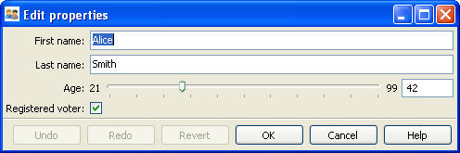
Figure 7
Notice that each trait is displayed in an appropriate widget although the code does not explictly specify any widgets at all. The two Str traits appear in text boxes, the Range is displayed using a combination of a text box and a slider, and the Bool is represented by a checkbox. Each is an implementation of the default trait editor (TextEditor, RangeEditor and BooleanEditor respectively) associated with the trait type.
Traits UI is by no means limited to these defaults, however. There are two ways to override the default representation of a trait attribute in a Traits UI window: explicitly specifing an alternate trait editor, and specifying an alternate style for the editor. The remainder of this chapter will examine these alternatives a little more closely.

Specifying an Alternate Trait Editor
As of this writing the Traits UI package includes twenty-six predefined trait editors:
Table 6
BooleanEditor | ButtonEditor | CheckListEditor | CodeEditor
ColorEditor | CompoundEditor | CustomEditor | DirectoryEditor
DropEditor | EnableRGBAColorEditor | EnumEditor | FileEditor
FontEditor | KivaFontEditor | ImageEnumEditor | InstanceEditor
ListEditor | PlotEditor | RangeEditor | RGBColorEditor
RGBAColorEditor | SetEditor | TableEditor | TextEditor
TreeEditor | TupleEditor
These editors are described in detail in Chapter 8.
For most predefined traits (see Traits User Manual), there is exactly one predefined trait editor suitable for displaying it: the editor that is assigned as its default. There are exceptions, however; for example, there are two different editors for displaying an RGBAColor trait: the RGBAColorEditor and the EnableRGBAColorEditor. A List trait can be edited by means of a ListEditor, a TableEditor (if the List elements are HasTraits objects), a CheckListEditor or a SetEditor. Furthermore, Traits UI includes tools for building additional trait editors as needed; we will see how this works in Chapter 9.
To use an alternate editor for a trait in a Traits UI window, you must specify it in the View for that window. This is done at the Item level, using the editor keyword attribute. The syntax of the specification is editor = <editor_name>(). (This syntax is also used for specifying that the default editor should be used, but with certain keyword attributes explicitly initialized; see Section 7.1.1.)
For example, if we wanted to display an RGBAColor trait called my_color using the default editor (RGBAColorEditor), our View might contain the following Item:
Item(name='my_color')
The resulting widget would then have the following appearance:
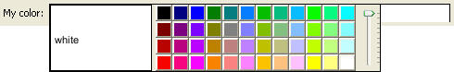
Figure 8
To use the EnableRGBAColorEditor instead, we would add the appropriate specification to the Item:
Item( name='my_color', editor=EnableRGBAColorEditor() )
The resulting widget would then appear as follows:
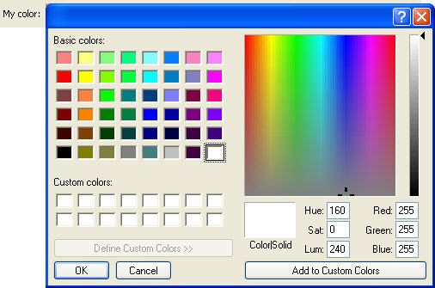
Figure 9
Caveat: Traits UI does not police the editor argument to ensure that the specified editor is appropriate for the trait being displayed. Thus there is nothing to prevent one from trying to, say, display a Float trait using a ColorEditor. The results of such a mismatch are unlikely to be helpful, and can even crash the application; it is up to the programmer to choose an editor sensibly. Chapter 8 is a useful reference for selecting an appropriate editor for a given task.

Initializing Editors
Many of the Traits UI trait editors can be used “straight from the box” as in the example above. There are some editors, however, that must be initialized in order to be useful. For example, the CheckListEditor and SetEditor both allow the user to edit a List by selecting elements from a specified set; the contents of this set must, of course, be known to the editor. This sort of initialization is usually performed by means of one or more keyword arguments to the editor’s constructor, e.g.:
Item(name=’my_list’,editor=CheckListEditor(values=["opt1","opt2","opt3"]))
The trait editor descriptions in Chapter 8 include a list of required and optional initialization keywords for each editor.

Specifying an Editor Style
In Traits UI, any given trait editor can be displayed in any of four different styles: simple, custom, text or readonly. These styles, which are described in general terms below, represent different “flavors” of data display, so that a given trait editor can look completely different in one style than in another. However, different trait editors displayed in the same style will (usually) have noticable characteristics in common. This is useful because editor style, unlike individual editors, can be set at the Group or View level, not just at the Item level. This point will be discussed further in Section 7.2.5.

The “simple” style
The simple editor style is designed to be as functional as possible while requiring minimal space within the GUI window. In ‘simple’ style, most of the Traits UI editors take up only a single of space in the window in which they are embedded.
In some cases, such as the TextEditor and BooleanEditor (see Section 8.1), the single line is fully sufficient. In others, such as the ColorEditor and EnumEditor, a more detailed interface is required; pop-ups or drop-downs are often used in such cases. For example, the “simple” version of the EnumEditor looks like this:
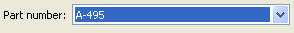

However, when the user clicks on the widget , a drop-down list appears:
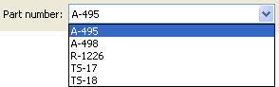
The “simple” editor style is most suitable for interface windows that must be kept small and concise.

The “custom” style
The custom editor style generally represents the most detailed version of any given editor. It is intended to provide maximal functionality and information without regard to the amount of window space used. For example, in the “custom” style the EnumEditor appears as a set of radio buttons rather than a drop-down list:
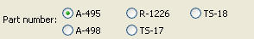
Figure 10
In the custom style of the RGBAColorEditor, the color palette is embedded in the window rather than appearing as a pop-up:
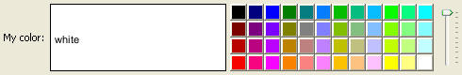
Figure 11
In general, the “custom” editor style can be very useful when there is no need to conserve window space, as it allows the user to see as much information as possible without having to interact with the widget. It also usually provides the most intuitive interface of the four.
Note that this style is not defined explicitly for all trait editors. If the “custom” style is requested for an editor for which it is not defined, the “‘simple” style is used instead.

The “text” style
The text editor style is the simplest of the editor styles. When applied to a given trait attribute, it presents a text representation of the trait in an editable box. Thus the EnumEditor in “text” style looks like the following:
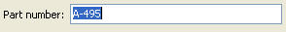
For this type of editor, it is the end user’s responsibility to type in a valid value for the attribute. If an incorrect value is typed, the trait validator for the attribute (see Traits User Manual) notifies the user of the error.
The text representation of an attribute to be edited in a “text” style editor is created in one of the following ways, listed in order of priority:
- The function specified in the format_func attribute of the Item (see Section 3.1.3), if any, is called on the attribute.
- Otherwise, the function specified in the format_func attribute of the trait editor (see Section 9.3.1.2), if any, is called on the attribute.
- Otherwise, the Python-style formatting string specified in the format_str attribute of the Item (see Section 3.1.3), if any, is used to format the attribute.
- Otherwise, the Python-style formatting string specified in the format_str attribute of the trait editor (see Section 9.3.1.2), if any, is used to format the attribute.
- Otherwise, the Python str() function is called on the attribute..

The “readonly” style
The readonly editor style is usually identical in appearance to the “text” style except that the attribute appears as static text rather than in an editable box:
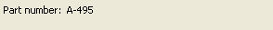
This editor style is used (naturally enough) to display data values without allowing the user to change them.

Using Editor Styles
As we have already seen in Chapters 3 and 4, the Item, Group and View objects of Traits UI all have a style attribute. The style of editor used to display the Items in a View is determined as follows:
- The editor style used to display a given Item is the value of its style attribute if specifically assigned. Otherwise the editor style of the Group or View that contains the Item is used.
- The editor style of a Group is the value of its style attribute if assigned. Otherwise, it is the editor style of the Group or View that contains the Group.
- The editor style of a View is the value of its style attribute if specified, and “simple” otherwise.
In other words, editor style can be specified at the Item, Group or View level, and in case of conflicts the style of the smaller scope takes precedence. For example, consider the following script:
Example 12
from enthought.traits.api import HasTraits, Str, Enum
from enthought.traits.ui.api import View, Group, Item

class MixedStyles(HasTraits):
first_name = Str
last_name = Str

department = Enum("Business", "Research", "Admin")
position_type = Enum("Full-Time", "Part-Time", "Contract")

traits_view = View(Group(Item(name='first_name'),
Item(name='last_name'),
Group(Item(name='department'),
Item(name='position_type',
style='custom'),
style='simple')),
title='Mixed Styles',
style='readonly')

ms = MixedStyles(first_name='Sam', last_name='Smith')
ms.configure_traits()
Notice how the editor styles are set for each attribute:
- position_type at the Item level
- department at the Group level
- first_name and last_name at the View level
The resulting window demonstrates the precedence rules we have just described:
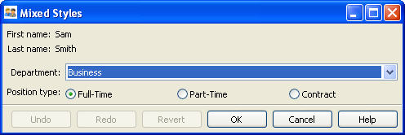
Figure 12

The Standard Trait Editors
This chapter contains individual descriptions of the twenty-six trait predefined trait editors provided by Traits UI. The majority of these editors are straightforward and can be used easily with little or no expertise on the part of the programmer or end user; these are described in Section 8.1. Section 8.2 covers a smaller set of specialized editors with more complex interfaces. Please note that the exact appearance of the editors will depend on the underlying GUI toolkit; the screenshots included in this chapter are based on wxPython, which is the only currently supported GUI platform.
Rather than trying to memorize all the information in this chapter, the reader is encouraged to skim it to get a general idea of the available trait editors and their capabilities, and to use it as a reference thereafter.

Basic Trait Editors

BooleanEditor
Suitable for | Bool
Default for | Bool
Required initialization | (none)
Optional initialization | mapping
The BooleanEditor is one of the simplest of the built-in editors in Traits UI, and is used exclusively to edit and display Bool (i.e, True/False) traits. In the “simple” and “custom” styles it appears as a checkbox. In the “text” style the editor displays the trait value (as one would expect) as the string “True” or “False”. However, several variations are accepted as input: ‘True’, ‘true’, ‘t’, ‘yes’ or ‘y’ for True, and ‘False’, ‘false’, ‘f’, ‘no’ or ‘n’ for False.
The set of acceptable text inputs can be changed by initializing the BooleanEditor attribute mapping to a dictionary whose entries are of the form <str>:<val>, where <val> is either True or False and <str> is a string that is acceptable as text input in place of that value. For example, to create a BooleanEditor that accepts only “yes” and “no” as appropriate text values, you might use the following expression:
editor=BooleanEditor(mapping={"yes":True, "no":False})
Note that in this case, the strings “True” and “False” would not be acceptable as text input.
Figure 13 shows the four styles of the BooleanEditor.
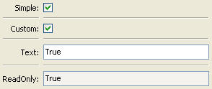
Figure 13

ButtonEditor
Suitable for | Button, Event
Default for | Button
Required initialization | (none)
Optional initialization | value, label
The ButtonEditor is designed to be used with an Event or Button trait. When a user clicks on a ButtonEditor button, the associated event is fired. Because events are not readable objects, the “text” and “readonly” styles are not implemented for this editor. The “simple” and “custom” styles of this editor are identical, as shown in Figure 14.
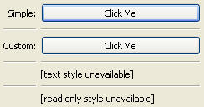
Figure 14
By default, the label of the button is the name of the Button or Event trait to which it is linked. However, this label can be set to any string by initializing the label attribute of the ButtonEditor with that string.

CheckListEditor
Suitable for | List
Default for | (none)
Required initialization | values
Optional initialization | cols
The CheckListEditor is designed to allow the user to edit a List trait by selecting elements from a “master list”, i.e., a list of possible values. The values trait of the CheckListEditor contains this master list, and must therefore be initialized when the editor is created.
The values trait can take either of two forms: a list of strings, or a list of tuples of the form (<element>, <label>), where <element> can be of any type and <label> is a string. In the latter case, the user selects from the labels, but the underlying trait is a List of the corresponding <element> values.
The “custom” style of this editor is displayed as a set of checkboxes. By default, these checkboxes are displayed in a single column; however, the programmer initialize the cols attribute of the editor to any value between 1 and 20, in which case the corresponding number of columns will be used.
The “simple” style of the CheckListEditor appears as a drop-down list; in this style only one list element can be selected, resulting in a singleton list. The “text” and “readonly” styles represent the current contents of the attribute in Python-style text format; in these cases the user cannot see the master list values that have not been selected.
The four styles of the CheckListEditor are shown in Figure 15. Note that in this case the cols attribute has been initialized to 4.
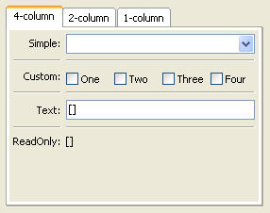
Figure 15

CodeEditor
Suitable for | Code, Str, String
Default for | Code
Required initialization | (none)
Optional initialization | auto_set, key_bindings
The purpose of the CodeEditor is, unsurprisingly, to display and edit Code traits, though it can be used with the Str and String trait types as well. In the “simple” and “custom” styles (which are identical for this editor), the text is displayed in numbered, nonwrapping lines with a horizontal scrollbar. The “text” style displays the trait using a single scrolling line with special characters to represent line breaks. The “readonly” style is similar to the “simple” and “custom” styles except that line numbers are not displayed and the text is wrapped (and, of course, not editable).
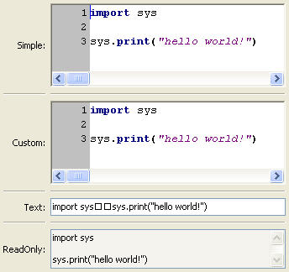
Figure 16
The auto_set keyword attribute is a Boolean value indicating whether the trait being edited should be updated with every keystroke (True) or only when the editor loses focus, i.e., when the user tabs away from it or closes the window (False). The default value of this attribute is True.

ColorEditor
Suitable for | Color
Default for | Color
Required initialization | (none)
Optional initialization | mapped
The ColorEditor is designed to allow the user to display a Color trait or edit it by selecting a color from the palette available in the underlying GUI toolkit. The four styles of this editor are shown in Figure 17.
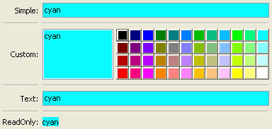
Figure 17
In the “simple” style, the editor appears as a text box whose background is a sample of the currently selected color. The text in the box is either a color name or a tuple of the form (r,g,b) where r, g, and b are the numeric values of the red, green and blue color components respectively. (Which representation is used depends on how the value was entered.) The text value is not directly editable in this style of editor; instead, clicking on the text box brings up a pop-up window similar in appearance and function to the “custom” ColorEditor style.
The “custom” style includes a labeled color swatch on the left, representing the current value of the Color trait, and a palette of common color choices on the right. Clicking on any tile of the palette changes the color selection, causing the swatch to update accordingly. Clicking on the swatch itself causes a more detailed interface to appear in a pop-up window, as shown in Figure 18.
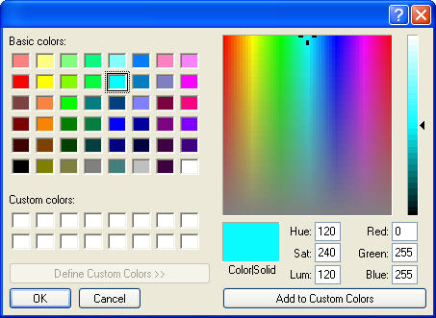
Figure 18
The “text” style of the ColorEditor looks exactly like the “simple” style, but the text box is editable (and clicking on it does not bring up a pop-up). It is the user’s responsibility to enter a recognized color name or a properly formatted (r,g,b) tuple.
The “readonly” style displays the text representation of the currently selected Color value (name or tuple) on a minimally-sized background of the corresponding color.
For advanced users: The mapped keyword attribute of the ColorEditor is a Boolean value indicating whether the trait being edited has a built-in mapping of user-oriented representations (e.g., strings) to internal representations. Since the ColorEditor is generally used only for Color traits, which are mapped (e.g., “cyan” to wx.Colour(0,255,255) ), this attribute defaults to True and will not be of interest to most programmers. However, it is possible to define a custom color Trait that uses the ColorEditor but is not mapped (i.e., uses only one representation), which is why the attribute is available.

CompoundEditor
Suitable for | special
Default for | (none)
Required initialization | (none)
Optional initialization | editors, auto_set
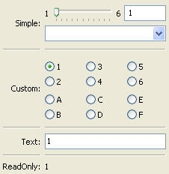
Figure 19

DirectoryEditor
Suitable for | Directory
Default for | Directory
Required initialization | (none)
Optional initialization | (none)
The DirectoryEditor is designed to allow the user to display a Directory trait or set it to some directory in the local system hierarchy. The four styles of this editor are shown in Figure 19.
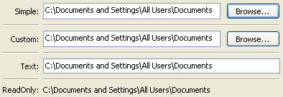
Figure 20
In the “simple” and “custom” styles (which are identical for this editor), the current value of the trait is displayed in a text box to the left of a “Browse…” button. The user can either type a new path directly into the text box or use the button to bring up a directory browser window as shown in Figure 20.
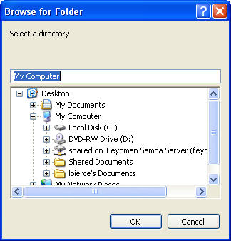
Figure 21
When the user selects a directory in this browser and hits “OK”, control is returned to the original editor widget, which is automatically populated with the new path string.
The “text” style of the editor is simply a text box into which the user can type a directory path. The “readonly” style is identical except that the text box is not editable.
No validation is performed on Directory traits; it is the user’s responsibility to ensure that a typed-in value is in fact an actual directory on the system.

EnableRGBAColorEditor
Suitable for | RGBAColor
Default for | (none)
Required initialization | (none)
Optional initialization | auto_set, mode, edit_alpha, text, font
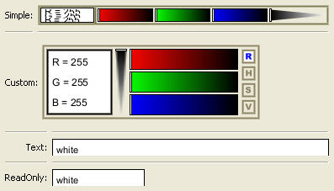
Figure 22
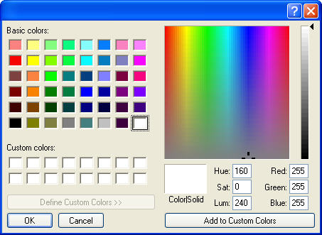
Figure 23

EnumEditor
Suitable for | Enum, Any
Default for | Enum
Required initialization | for non-Enum traits: values or name, object
Optional initialization | evaluate, cols, mode
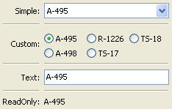
Figure 24
By default, the EnumEditor sorts its values alphabetically. If you want to specify a different order for the items, you can give it a mapping from the normal values to ones with a numeric tag. The EnumEditor sorts the values based on the numeric tags, and then strips out the tags. For example:
from enthought.traits.api import HasTraits, Trait
from enthought.traits.ui.api import EnumEditor

Class EnumExample(HasTraits):
priority = Trait(‘Medium’, ‘Highest’,
‘High’,
‘Medium’,
‘Low’,
‘Lowest’)

view = View( Item(name=’priority’,
editor=EnumEditor(values={
‘Highest’ : ‘1:Highest’,
‘High’ : ‘2:High’,
‘Medium’ : ‘3:Medium’,
‘Low’ : ‘4:Low’,
‘Lowest’ : ‘5:Lowest’, })))
The EnumEditor strips off the characters up to and including the colon. It assumes that all the items have the colon in the same column; therefore, if some of your tags have multiple digits, you should use zeros to pad the items with fewer digits.

FileEditor
Suitable for | File
Default for | File
The FileEditor is designed to allow the user to display a File trait or set it to some file in the local system hierarchy. The four styles of this editor are shown in Figure 24.
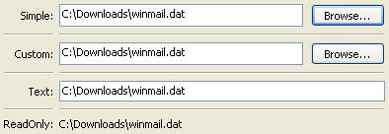
Figure 25
The behavior and appearance of this editor are very similar to those of the DirectoryEditor, except that the “Browse…” button activates a file browser rather than a directory browser, as shown in Figure 25.
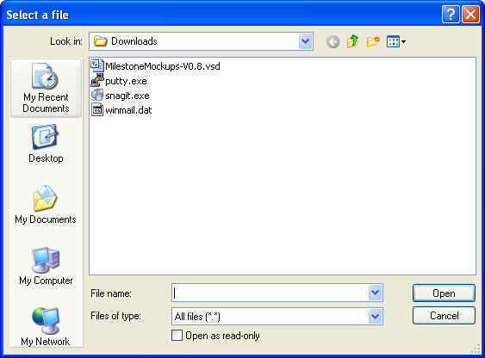
Figure 26

FontEditor
Suitable for | Font
Default for | Font
Required initialization | (none)
Optional initialization | (none)
The FontEditor allows the user to display a Font trait or edit it by selecting one of the fonts provided by the underlying GUI toolkit. The four styles of this editor are shown in Figure 26.
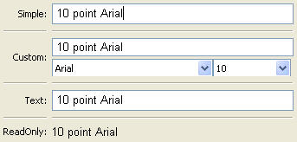
Figure 27
In the “simple” style, the currently selected font appears in a display similar to a text box, except that when the user clicks on it, a pop-up dialog appears with the detailed interface shown in Figure 27. Once the user hits “OK”, control returns to the editor, which then displays the newly selected font.
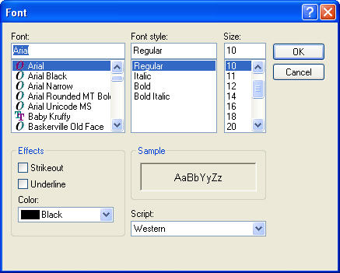
Figure 28
In the “custom” style, an abbreviated version of the font dialog is displayed in-line. The user can either type the name of the font in the text box or use the two drop-down lists to select a typeface and size.
In the “text” style, the user must type the name of a font in the text box provided. No validation is performed; it is the user’s responsibility to enter the correct name of an available font. The “readonly” style is identical except that the text box is not editable.

KivaFontEditor
Suitable for | KivaFont
Default for | KivaFont
Required initialization | (none)
Optional initialization | (none)
This editor is identical in appearance and function to the FontEditor, except that it is used to display and edit KivaFont traits.

ListEditor
Suitable for | List
Default for | List
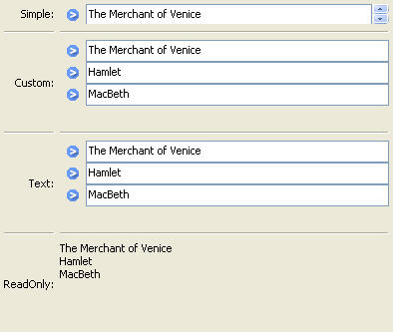
Figure 29
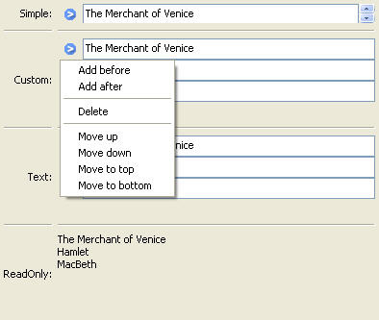
Figure 30

RangeEditor
Suitable for | Range
Default for | Range (all types)
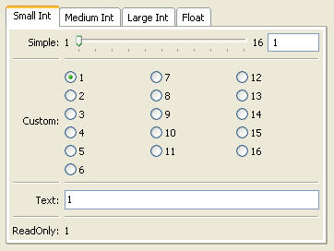
Figure 31
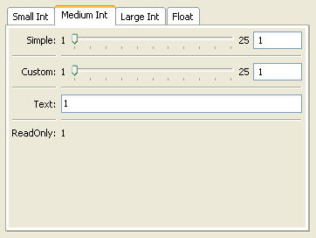
Figure 32
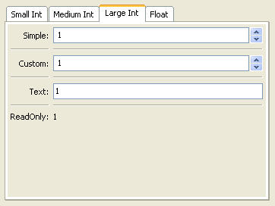
Figure 33
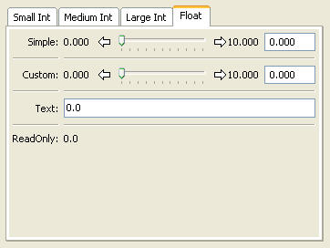
Figure 34

RGBColorEditor
Suitable for | RGBColor
Default for | RGBColor
(Identical in appearance to ColorEditor)

RGBAColorEditor
Suitable for | RGBAColor
Default for | RGBAColor
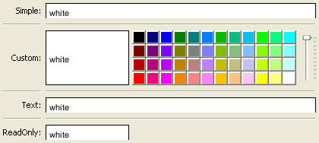
Figure 35
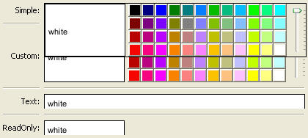
Figure 36
Figure 37

SetEditor
Suitable for | List
Default for | none
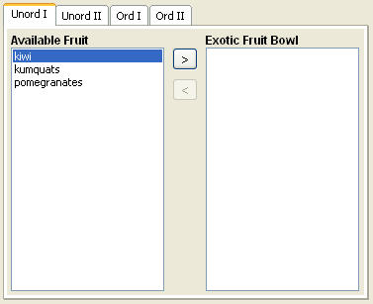
Figure 38
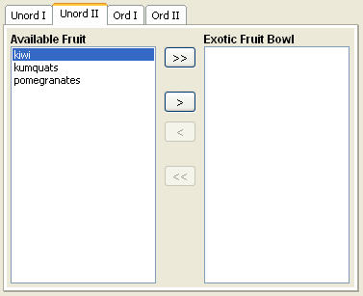
Figure 39
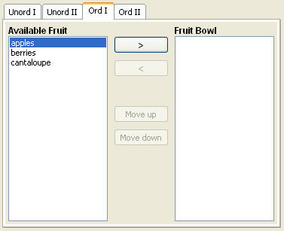
Figure 40
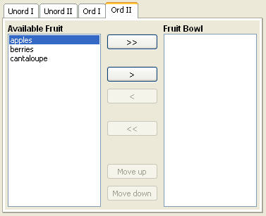
Figure 41

TextEditor
Suitable for | all
Default for | Str, String, Password, Int, Float, special
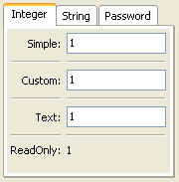
Figure 42
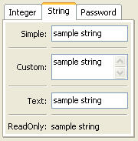
Figure 43
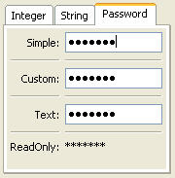
Figure 44

TupleEditor
Suitable for | Tuple
Default for | Tuple
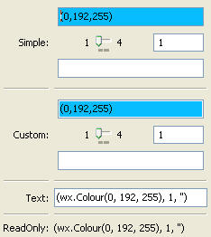
Figure 45

Advanced Trait Editors

CustomEditor

DropEditor

ImageEnumEditor
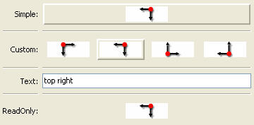
Figure 46

InstanceEditor

PlotEditor

TableEditor
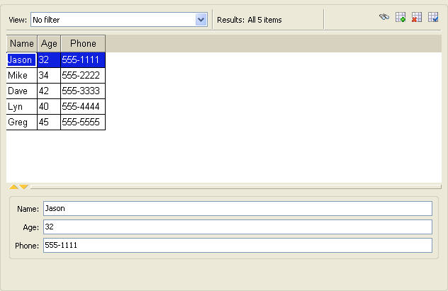
Figure 47

TreeEditor

Advanced Editor Concepts

Interacting with an Editor Through the UI Object

Accessing Trait Editors Using Item ‘id’s

Controlling Editor Status Using ‘enabled/disabled’

Introduction to Editor Factories

Defining a Custom Editor

Defining the Editor Factory

Standard Traits: format_str, format_func, is_grid_cell

Standard methods: init(), simple_editor(), custom_editor(), text_editor(), readonly_editor(), format_func()

Defining the Editor

Standard Traits: ui, object, name, old_value, description, control, enabled, factory, updating, value, str_value

Standard methods: init(), dispose(), update_editor(), error(), string_value(), save_prefs(), restore_prefs(), get_undo_item()

Miscellaneous Advanced Topics

The UI Object

The UIInfo Object Revisited

Defining a Custom Help Handler

Saving and Restoring User Preferences
(which preferences can be saved, how to save and restore preferences)

Enabling User Preferences for a View

The View id

The Item id

Tips, Tricks and Gotchas

Getting/Setting Model View Elements
For some applications, it can be necessary to retrieve or manipulate the View objects associated with a given model object. The HasTraits class defines two methods for this purpose: trait_views() and trait_view().

trait_views()
The trait_views() method, when called without arguments, returns a list containing the names of all Views defined in the object's class. For example, if sam is an object of type SimpleEmployee3 (from Example 6), the method call sam.trait_views() returns the list ['all_view', 'traits_view'].
Alternatively, a call to obj.trait_views(view_element_type) returns a list of all named instances of class view_element_type defined in obj's class, where the possible values of view_element_type are View, Group, Item, ViewElement, and ViewSubElement. Thus calling trait_views(View) is identical to calling trait_views(). Note that the call sam.trait_views(Group) returns an empty list, although both of the Views defined in SimpleEmployee contain Groups. This is because only named elements are returned by the method.
Group and Item are both subclasses of ViewSubElement, while ViewSubElement and View are both subclasses of ViewElement. Thus a call to trait_views(ViewSubElement) returns a list of named Items and Groups, while trait_views(ViewElement) returns a list of named Items, Groups and Views.

trait_view()
The trait_view() method is used for three distinct purposes:
- To retrieve the default View associated with an object
- To retrieve a particular named ViewElement (i.e., Item, Group or View)
- To define a new named ViewElement

For example:
- obj.trait_view() returns the default View associated with object obj. For example, sam.trait_view() returns the View object called 'traits_view'. Note that unlike trait_views(), trait_view() returns the View itself, not its name.
- obj.trait_view('my_view') returns the view element named 'my_view' (or None if 'my_view' is not defined).
- obj.trait_view('my_group', Group('a', 'b')) defines a Group with the name 'my_group'. Note that although this Group can be retrieved using trait_view(), its name will not appear in the list returned by traits_view(Group). This is because 'my_group' is associated with obj itself, rather than with its class.
This last usage will be particularly useful in conjunction with parameterized views once they are fully supported (see Section 5.5).
Appendix I: Glossary of Terms
attribute: An element of data associated with all instances of a given class, and named at the class level. In most cases, attributes are stored and assigned separately for each instance (for the exception, see class attribute). Synonyms include “data member” and “instance variable”.
Bool: The trait type of a Boolean attribute.
Boolean: Having only True or False as possible values.
controller: The element of the MVC (“model-view-controller”) design pattern that manages the transfer of information between the data model and the “view” used to observe and edit it.
data member: Synonym for “attribute”.
dialog box: A window whose purpose is to allow a user to interact with a program, usually by entering data.
dictionary: A lookup table of the form {key1: value1, key2: value2, … key_n: value_n}, implemented as a built-in type in the Python language. Values are inserted and retrieved by key rather than by offset (as they would be in Python lists or in C-style arrays).
editor: A user interface component for editing the value of a trait attribute. Each type of trait has a default editor, but the user-programmer can override this selection with one of a number of editor types provided by the Traits UI package. In some cases an editor can include multiple widgets, e.g., a slider and a text box for a Range trait attribute.
editor factory: An instance of the Traits class EditorFactory.
factory: An object used to produce other objects at run time without necessarily assigning them to named variables or attributes. A single factory is often parameterized to produce instances of different classes as needed.
Group: An object that specifies an ordered set of Items and other Groups for display in a Traits UI View. Various display options can be specified by means of attributes of this class, including a border, a group label, and the orientation of elements within the Group. An instance of the Traits UI class Group.
Handler: A Traits UI object that implements GUI logic (data manipulation and dynamic window behavior) for one or more user interface windows. An instance of the Traits UI class Handler.
HasTraits: A class defined in Traits to specify objects whose attributes are typed (i.e., are “trait attributes”).
instance: A concrete entity belonging to an abstract category such as a class. In object-oriented programming terminology, an entity with allocated memory storage whose structure and behavior are defined by the class to which it belongs. Often called an “object”.
instance method: A method that is performed on (and called through) a specific instance, usually using a syntax like object1.do_this().
instance variable: Synonym for “attribute”.
Item: A non-subdividable element of a Traits user interface specification (View), usually specifying the display options to be used for a single Trait attribute. An instance of the Traits UI class Item.
live: A term used to describe a dialog box that is linked directly to the underlying model data, so that changes to data in the interface are reflected immediately in the model. A dialog box that is not live displays and manipulates a copy of the model data until the user confirms any changes.
livemodal: A term used to describe a dialog box that is both live and modal.
MVC: A design pattern for interactive software applications. The initials stand for “Model-View-Controller”, the three distinct entities prescribed for designing such applications. (See the glossary entries for model, view, and controller.)
modal: A term used to describe a dialog box that causes the remainder of the application to be suspended, so that the user can interact only with the dialog box until it is closed.
model: A component of the MVC design pattern for interactive software applications. The model consists of the set of classes and objects that define the underlying data of the application, as well as any internal (i.e., non-GUI-related) methods or functions on that data.
nonmodal: A term used to describe a dialog box that is neither live nor modal.
object: Synonym for “instance”.
object method: Synonym for “instance method”.
panel: A construct similar to a window except that it is embedded in a larger window rather than existing independently.
predefined trait: Any trait type that is built into the Traits package.
regular expression: A way of specifying a set of strings by encoding its syntax requirements as a single string rather than by enumerating all its members.
subpanel: A variation on a panel that ignores (i.e., does not display) any command buttons.
trait: A term used loosely to refer to either a “trait type” or a “trait attribute”.
trait attribute: An attribute whose type is specified and checked by means of the Traits package.
trait type: A type-checked data type, either built into or implemented by means of the Traits package.
Traits: An Open Source package engineered by Enthought, Inc. to perform manifest typing in Python.
Traits UI: A high-level user interface toolkit designed to be used with the Traits package.
tuple: An ordered set of Python objects, not necessarily of the same type. The syntax for tuples differs from that of Python lists in that parentheses are used (and , in some contexts, omitted) rather than square brackets, e.g. tuple1 = ("hello", 3, True).
View: A template object for constructing a GUI window or panel for editing a set of traits. The structure of a View is defined by one or more Group and/or Item objects; a number of attributes are defined for specifying display options including height and width, menu bar (if any), and the set of buttons that will be available. A member of the Traits UI class View.
view: A component of the MVC design pattern for interactive software applications. The view component encompasses the visual aspect of the application, as opposed to the underlying data (the model) and the application’s behavior (the controller).
ViewElement: A View, Group or Item object. The ViewElement class is the parent of all three of these subclasses.
widget: An interactive element in a graphical user interface, e.g., a scrollbar, button, pull-down menu or text box.
wizard: An interface composed of a series of dialog boxes, usually used to guide a user through an interactive task such as software installation.
wx: A shorthand term for the low-level GUI toolkit on which TraitsUI and PyFace are currently based (wxwidgets) and its Python wrapper (wxPython).
Appendix II: Default Editors for Standard Traits

A third type of content object, Include, is discussed briefly in Chapter 5, but presently is not commonly used.
Not to be confused with the TraitHandler class of the Traits package, which enforces type validation.
If the code is being run from a program that already has a GUI defined, then use edit_traits() instead of configure_traits(). These methods are discussed in more detail in Section 5.4.
A View can also specify window behavior to a limited extent; see Sections 3.1.5 and 3.2.3.
As with Views, it is possible for a Group to contain objects of more than one type, but not recommended (see Section 3.2.5).
Actually, the value of the buttons attribute is really a list of Action objects, from which GUI buttons are generated by Traits UI. The Action class is described in Section 6.2.
Note that although the definition of a View within a HasTraits class has the syntax of a trait attribute definition, the resulting View is not stored as an attribute of the class. See Section 11.1 for information on how to access such Views.
Assuming there is one; not all GUIs require an explicitly defined Handler.
One possible exception is the case where a View object is defined as a variable (i.e., outside any class) or within a custom Handler, and is associated more or less equally with multiple model objects; see Section 5.4.1: “Multi-Object Views”.
If the script were designed to run within an existing GUI, it would make sense to replace the last line with "comp_view.ui(context={'h1': house1, 'h2': house2})", since neither object particularly dominates the view. However, the examples in this Guide are designed to be fully executable from the Python command line, which is why configure_traits() was used instead.
Except those implemented via the enabled_when, visible_when, and defined_when attributes of Items and Groups.
Other attributes of the UIInfo object include a UI object (see Section 10.1) and any trait editors contained in the window (see Chapters 7-9). The use of these UIInfo attributes is discussed in Section 10.2.
Appendix II contains a table of the predefined trait types in the Traits package and their default trait editor types.
In Traits, a Button and an Event are essentially the same thing, except that Buttons are automatically associated with ButtonEditors.
Traits UI makes minor modifications to the name, capitalizing the first letter and replacing underscores with spaces, as in the case of a default Item label (see Section 3.1.2).
If a List is made up of HasTraits objects, the TableEditor is used as the default instead; see Section 8.2.6.
This is not always the case in Python, where attributes can be added to individual objects.
A method can, of course, have arguments. They are omitted from the sample syntax for simplicity.

